Library Assessment Team Report, LibQual+ Survey Results

The Assessment Team’s major project for the last academic year was conducting the LibQual+ survey. The survey was previously conducted in 2005 and 2010. We moved the schedule up, a year ahead of the normal cycle, in order to get results prior to the implementation of Primo. As in 2010, we chose the “Lite” version of the survey, which randomizes the core questions to makes it shorter for each respondent.
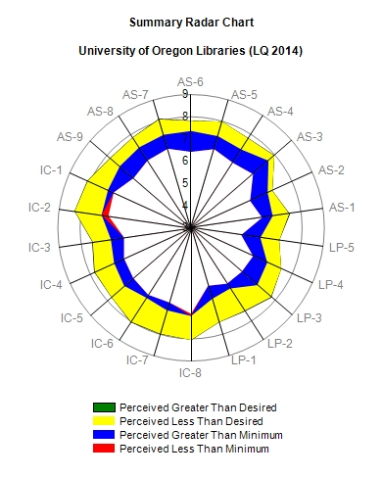
In April 2014 we had an overall response rate of just 7%, in spite of multiple reminder messages. (The response rate was 11% in 2010.) The faculty response rate was 9%, graduate students 15%, and undergraduates 5%. We conducted a representativeness check comparing respondents with the overall campus population by discipline. In general the 7% who did respond appear to mirror the campus population pretty closely with the exception of underrepresentation from Business and slight overrepresentation from Humanities.
In addition to the general satisfaction questions, the LibQual+ survey measures the user’s perceived service level, minimum acceptable service level, and desired service level along three major dimensions: Affect of Service-AS (how users feel they are treated); Information Control-IC (library collections, website, and discovery tools); and Library as Place-LP (physical facilities). Reading the radar chart: blue is good, yellow is not so good, red is really not good.
The actual questions are listed at the end of this report.

Looking at the responses to specific questions where is the biggest GAP between the current service level and what our users really want?
From the Undergraduate perspective:
- Quiet space for individual activities (LP2)
- Community space for group learning and group study (LP5)
From the Graduate Student perspective:
- Ability to navigate web pages easily (Local question – close to IC2)
- Ease and timeliness in getting materials from other libraries
(Local question – numbers look a lot like IC7 on the radar chart)
From the Faculty perspective:
- Ability to navigate web pages easily (Local question – close to IC2)
- Print and/or electronic journal collections I require for my work (IC8)

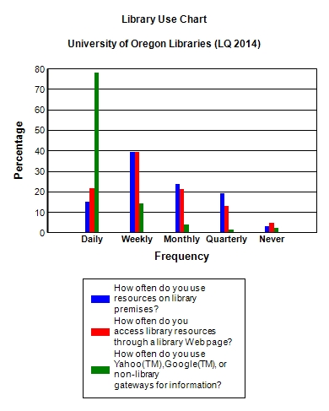
Use of the physical and virtual library

Trends: General Satisfaction Questions - all users - on a scale of 1 to 9, with 9 being high):
Question | 2005 | 2010 | 2014 | Change 2010 to 2014
I am satisfied with the way in which I am treated at the library. | 7.34 | 7.42 | 7.57 | +0.15
I am satisfied with library support for my learning, research, and/or teaching needs. | 6.92 | 6.83 | 7.1 | +0.27
Rating of the overall quality of service provided by the library. | 7.19 | 7.08 | 7.25 | +0.17

Trends: Perceived level of service showed improvement along all major dimensions:

The greatest statistically significant change in response to a specific question from 2010 to 2014: Making electronic resources accessible from my home or office.
This is on a scale of 1-9, with 9 being high. There are similar changes in faculty responses to this question.

Survey comments/qualitative data: The 675 valid survey responses yielded 316 open-ended comments.
65 related to physical facilities:
More study space 28 comments
Enforce quiet/more quiet areas 13 comments
Better lighting 9 comments
Better temperature control 5 comments
More comfortable furniture 5 comments
Cleanliness 5 comments
More/different hours 3 comments
86 comments related to the dimension of information control:
Difficulty navigating web pages/discovery tools 29 comments
Inadequate collections (print or electronic) 44 comments
Positive or neutral reflections on collections 13 comments
86 comments related to library service:
Interlibrary loan (all positive) 9 comments
Kudos to a specific subject specialist 12 comments
Other positive comments on services 38 comments
Negative comments about services 20 comments
Complaints about policies (fees/loan rules) 7 comments

Standard Survey Questions:
Affect of Service
AS-1 Employees who instill confidence in users
AS-2 Giving users individual attention
AS-3 Employees who are consistently courteous
AS-4 Readiness to respond to users' questions
AS-5 Employees who have the knowledge to answer user questions
AS-6 Employees who deal with users in a caring fashion
AS-7 Employees who understand the needs of their users
AS-8 Willingness to help users 6.61 7.85 7.31 0.70 -0.54 142
AS-9 Dependability in handling users' service problems
Information Control
IC-1 Making electronic resources accessible from my
home or office
IC-2 A library Web site enabling me to locate information on my own
IC-3 The printed library materials I need for my work
IC-4 The electronic information resources I need
IC-5 Modern equipment that lets me easily access needed information
IC-6 Easy-to-use access tools that allow me to find things on my own
IC-7 Making information easily accessible for independent use
IC-8 Print and/or electronic journal collections I require for my work
Library as Place
LP-1 Library space that inspires study and learning
LP-2 Quiet space for individual activities
LP-3 A comfortable and inviting location
LP-4 A getaway for study, learning, or research
LP-5 Community space for group learning and group study

Local (optional) Questions:
- Ability to navigate web pages easily
- Ease and timeliness in getting materials from other libraries
- Helpful online guides and tutorials
- Providing help when and where I need it
- Teaching me how to locate, evaluate, and use information

Nancy Slight-Gibney, 9Dec2014

